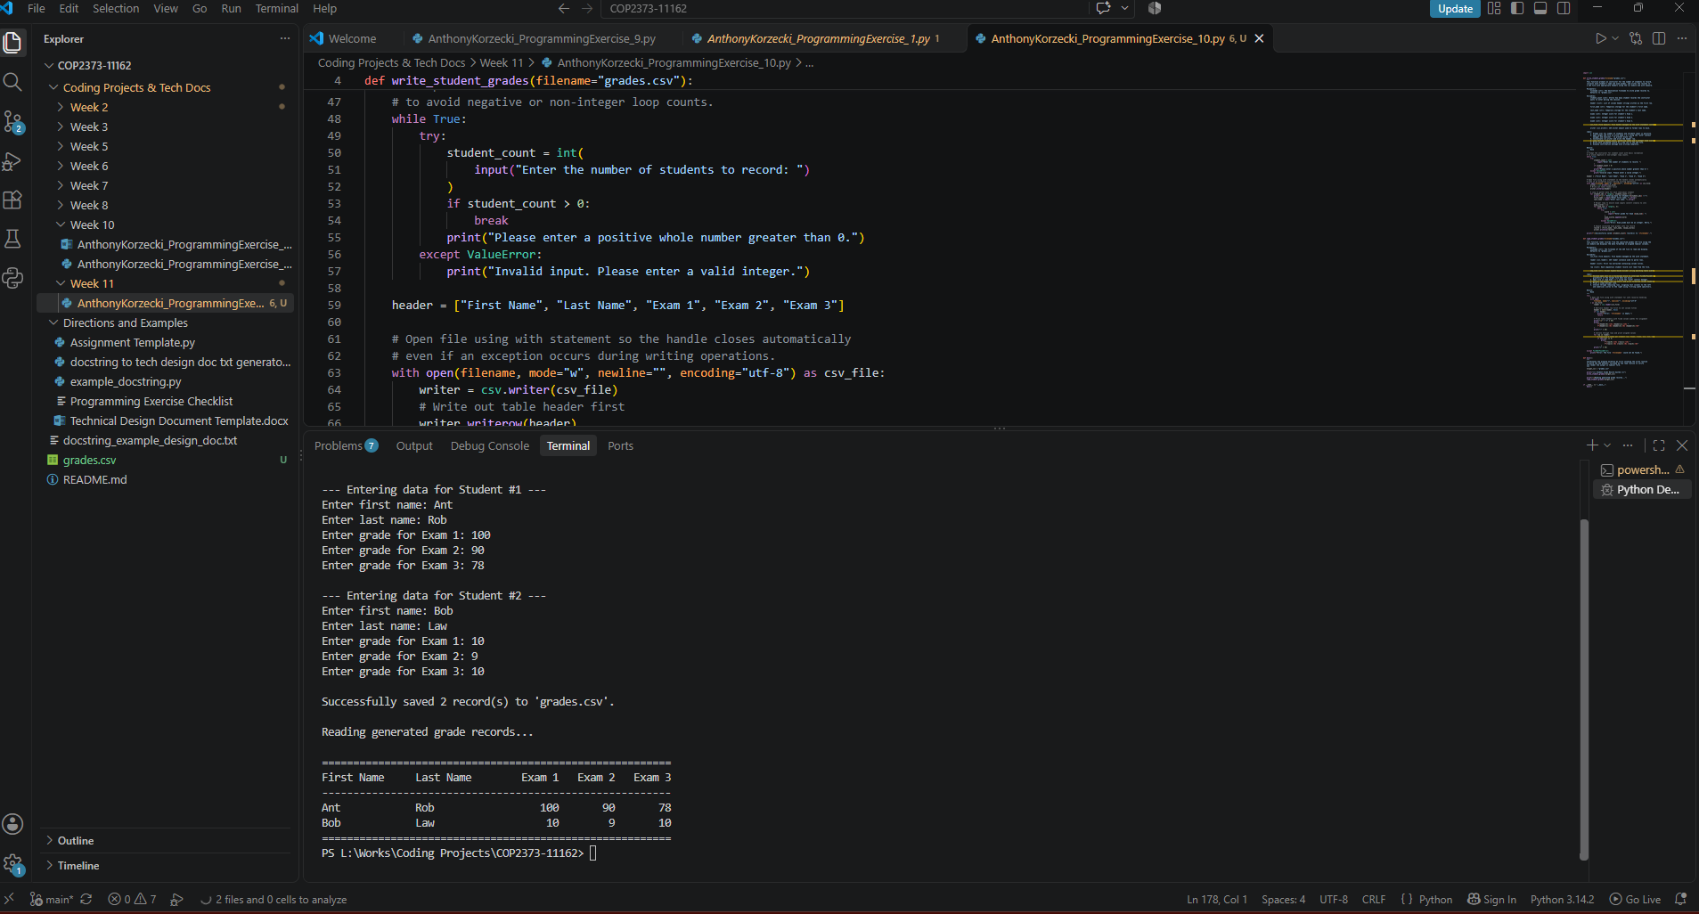
# Technical Design Document: AnthonyKorzecki_ProgrammingExercise_8

# Name: Anthony Korzecki
# Date: November 1, 2026
# Program Description: This program prompts an instructor for a count of students, collects each student's first name, last name, and three integer exam scores, and writes the records to a CSV file named grades.csv with column headers using the csv module and the with keyword. It then reads the CSV file back in and outputs the student records in an aligned tabular format.

## Function: write_student_grades
This function prompts an instructor for the number of students to record,
collects each student's name and exam grades, and writes the records to
a CSV file with appropriate headers using the csv module and with keyword.

Parameters:
filename (str): The destination filename to write grade records to.
Defaults to "grades.csv".

Variables:
student_count (int): Stores how many student records the instructor
wants to enter during the session.

header (list): List of column header strings written as the first row.

first_name (str): Temporary storage for the student's first name.

last_name (str): Temporary storage for the student's last name.

exam_scores (list): List holding the three validated integer scores
entered for a student.

record (list): Complete row containing first name, last name,
and three exam scores.

csv_file (file object): File handle managed by the with statement context.

writer (csv.writer): CSV writer object used to format rows to disk.

Logic:
1. Prompt user for number of students and validate input is positive.
2. Open target CSV file in write mode ('w') using the "with" context
manager and newline='' to prevent blank rows.
3. Instantiate csv.writer and write the header row.
4. Loop through student_count, gathering names and 3 integer exam scores.
5. Write each validated record as a new row in the CSV file.
6. Display confirmation message once writing completes.

Return:
None

## Function: read_student_grades
This function reads records from the specified grades CSV file using the
csv module and displays the data formatted in aligned tabular columns[cite: 1].

Parameters:
filename (str): The filename of the CSV file to read and display.
Defaults to "grades.csv"[cite: 1].

Variables:
csv_file (file object): File handle managed by the with statement[cite: 1].

reader (csv.reader): CSV reader instance used to parse rows[cite: 1].

header (list): First row extracted containing column titles[cite: 1].

row (list): Each sequential student record list read from the file[cite: 1].

Logic:
1. Enclose open call in a try/except block to intercept FileNotFoundError
gracefully if the target file does not exist[cite: 1].
2. Open file in read mode ('r') using the "with" context manager[cite: 1].
3. Extract the header row via next() and print formatted column headers[cite: 1].
4. Print a clean divider line[cite: 1].
5. Iterate through remaining rows, aligning text columns to the left
and numerical scores to the right using f-string width specifiers.

Return:
None

## Function: main
Coordinates the program workflow by first invoking the write routine
to build the CSV dataset, followed by the read routine to verify
and render the output in tabular form.

Parameters:
None

Variables:
target_csv (str): String holding the name of the file to write to
and read from ("grades.csv").

Logic:
1. Set the target CSV filename string.
2. Print introductory program header.
3. Invoke write_student_grades() to collect student data and generate
the CSV file.
4. Invoke read_student_grades() to read and print the records
in tabular format.

Return:
None

# Link to your repository: https://github.com/akorzecki/COP2373-11162

